**Quantitative Methods 2019-2020**

**Individual Portfolio**

**Referral/Deferral Semester**

**ID:00010384**

**Question 1A.**

This is **ratio** data, because time is data, data is ordered, labeled and zero means nothing.

**Question 2A.**

|  |  |  |
| --- | --- | --- |
| **Score range (x)** | **Number of students (f)** | **Relative Frequency** |
| (20-29) | 123 | $$\frac{123}{1225}=0.10$$ |
| (30-39) | 185 | $$\frac{185}{1225}=0.15$$ |
| (40-49) | 343 | $$\frac{343}{1225}=0.28$$ |
| (50-59) | 261 | $$\frac{261}{1225}=0.21$$ |
| (60-69) | 190 | $$\frac{190}{1225}=0.15$$ |
| (70-79) | 123 | $$\frac{123}{1225}=0.10$$ |
| **Total** | 1225 | 1 |

**Question 3B.**

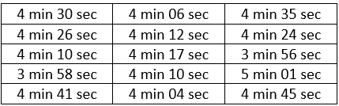

$$\frac{\sum_{k=1}^{n}{x_{k}}}{n}$$

$\frac{270+266+250+238+281+246+252+257+250+244+275+264+236+301+285}{15}=\frac{3915}{15}$ =261

**The mean is equal to 261 (sec) = 4min 21sec.**

**Question 4B.**

|  |  |  |  |  |  |
| --- | --- | --- | --- | --- | --- |
| **X** | **F** | **Xmidpoint** | **Xmidpoint- x̃** | **(Xmidpoint- x̃)2** | **F* (Xmidpoint- x̃)2** |
| 0-30 | 120 | 15 | -36 | 1296 | 155520 |
| 30-40 | 190 | 35 | -16 | 256 | 48640 |
| 40-50 | 280 | 45 | -6 | 36 | 10080 |
| 50-60 | 370 | 55 | 4 | 16 | 5920 |
| 60-70 | 200 | 65 | 14 | 196 | 39200 |
| 70-100 | 140 | 85 | 34 | 1156 | 161840 |
| **Total** | 1300 | 300 |  |  | 421200 |

**Standard Deviation = $\sqrt{\frac{{∑f\left(x-\tilde{x}\right)}^{2}}{∑f}}$**

$\frac{421200}{1300}=18$

**The Standard Deviation is equal to 18.**

**Question 5B.**

 P(x)=nCx*Px*(1 – P)n – x=25C15*0.4515*0.5510= 0.4515 * 0.5510=0.5202

**0.5202 ≈ 52%**

**There is 52% chance that 15 people out of 25 chosen at random are immune to this disease.**

**Question 6B.**

|  |  |  |  |  |
| --- | --- | --- | --- | --- |
|  | **I** | **II** | **III** | **IV** |
| 2016 |  |  | 4.77 | -1.74 |
| 2017 | -5.29 | 2.14 | 4.66 | -1.64 |
| 2018 | -4.86 | 1.59 |  |  |
| Total | -10.15 | 3.73 | 9.43 | -3.38 |
| Average | -5.07 | 1.86 | 4.71 | -1.69 |
| Adjustment | -0.04 | -0.04 | -0.04 | -0.04 |
| **Seasonal Variation** | **-5.03** | **1.82** | **4.75** | **-1.65** |

**Question 7A**

|  |  |  |  |
| --- | --- | --- | --- |
| **x** | **f** | **xmidpoint** | **Cumulative frequency** |
| 0-30 | 120 | 15 | 120 |
| 30-40 | 180 | 35 | 300 |
| 40-50 | 350 | 45 | 650 |
| 50-60 | 260 | 55 | 910 |
| 60-70 | 190 | 65 | 1100 |
| 70-100 | 120 | 75 | 1220 |
| **Total** | 1220 |  |  |

**Median= L+W($\frac{\frac{n}{2}-f}{f})$ = 40+10*0.885=48.85**

**Median is equal to 49**

**Question 8A.**

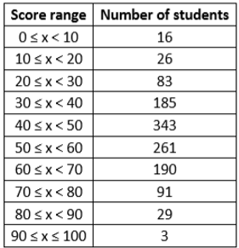

16+26+83+185+343+261+190+91+29+3=1227

1227 = 100%

123 = x%

**X= 10%**

**There is a 10% chance that a student chosen at random has a mark of 70 or higher.**

**Question 9A.**

Coin 23=8

Dice 43=64

8*64=**512**

**There are 512 outcomes are possible.**

**Question 10A.**

As alpha cannot be negative 70 is the maximal esteem of alpha is says: The range is from 0 to 70 as the number of hours cannot be more than 70/3 and or less than zero.